## horizontal line



Enhance an existing project

Christine Matta

# 

# Overview

The project is a Todo list application that allow the user to do the following:

* Add new Todos
* Modify existing Todos
* Delete Todos
* Mark every separate todo as active or completed
* Mark all todos as active or completed
* Display only all, active or completed Todos
* Clear all completed Todos

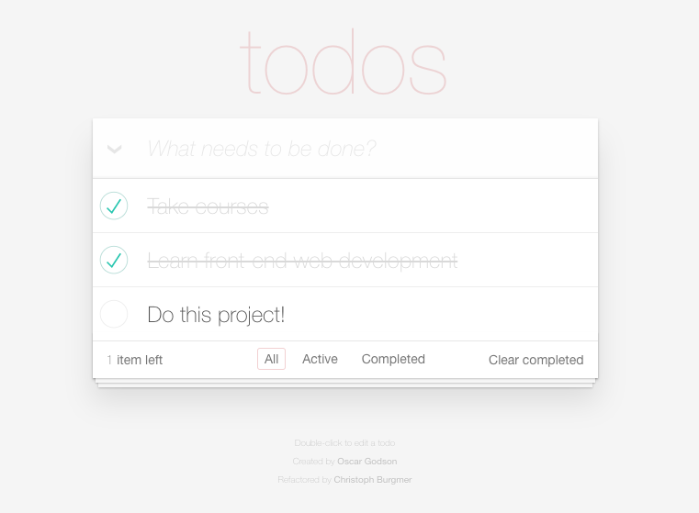

# Requirements

#### **Fix the bugs**

#### **Add tests**

#### **Analyze performance**

#### **Write technical documentation**

# How to access the Todo App.

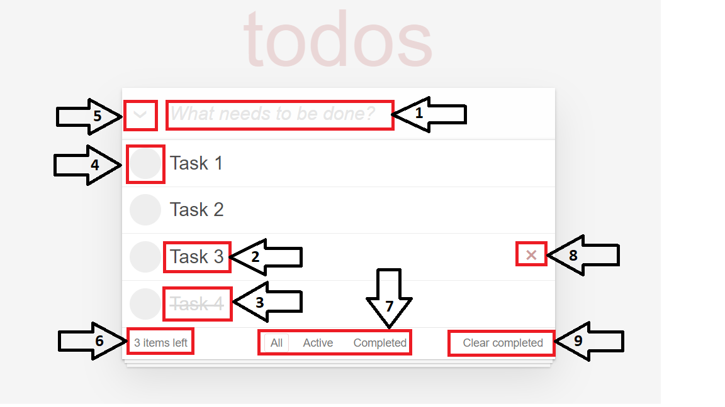

## 

## 

## 

## Write down your Todo task and then press Enter to add a new todo to the todo list

## You can rename the todo item by double clicking on it and press enter after editing.

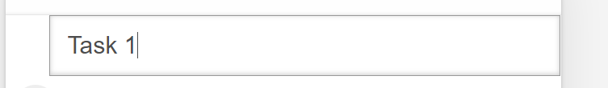

## When change the status to completed the css style change to dimed label

## To change the status of active todo to completed or vice versa click this box.

## To change the status of all active todos to completed or vice versa click this field.

## You can view how many active Todos are still remaining.

## This filter buttons have 3 taps All, active and completed, you can filter depending on your desire

## To remove a toto item from the list , hover on this item and then click the X button

## To remove all completed todos click this element.

# MVC architecture

## **Features of MVC**

* + Easy and frictionless testability. Highly testable framework
  + Offers full control over your HTML as well as your URLs
  + Clear separation of logic: Model, View, Controller.
    - Separation of application tasks
    - Business logic
    - Ul logic
    - input logic
  + Supports for Test Driven Development (TDD

## **MVC Architecture**

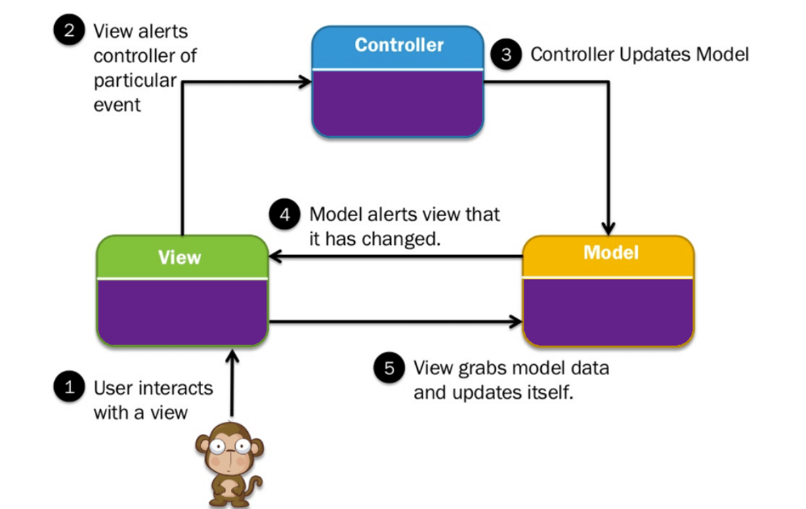

## 

## 

## **Three important MVC the components are:**

## Model: It includes all the data and its related logic

## View: Present data to the user or handles user interaction

## Controller: An interface between Model and View components

## **MODE**

## Model is responsible for managing the data of the application. It receives user input from the controller. He is responsible for CRUD (create, read, update and delete) operations. Our model is using local storage to save our todos.

## **VIEW**

## View is a presentation of the model in a particular format - in our case displaying All, Active or Completed todos (route). It also lets the user interact with displayed data.

## **CONTROLLER**

## Controller responds to the user input from View and performs interactions with Model. It also reads data from Model and passes it to the view.

## By using MVC architecture our application works like Single Page Application (SPA) - that means user can interact with todos without reloading webpage.

## 

# Bugs fixing

### **Bug which does not allow adding new todos to the list**

LOCATION: controller.js *line 95*

**Controller.prototype.adddItem = function (title) {**

has been changed into

**Controller.prototype.addItem = function (title) {**

### **Bug which may leads to potential conflict between duplicate IDs**

LOCATION: store.js starting from line 84

**var newId = "";**

**var charset = "0123456789";**

**for (var i = 0; i < 6; i++) {**

**newId += charset.charAt(Math.floor(Math.random() * charset.length));**

**}**

has been changed into

**var newId = new Date().getTime();**

# 

# 

# 

# 

# Adding tests

Tests have been created by using Jasmine.

Jasmine is an open source testing framework for JavaScript.

To start the test simply start SpecRunner.html file located in application main directory in test folder.

To create or modify tests open and modify ControllerSpec.js file located in the same directory.

# should show entries on start-up

# should show active entries

# should show completed entries

# should highlight "All" filter by default

# should highlight "Active" filter when switching to active view

# should toggle all todos to completed

# should add a new todo to the model

# 

# should update the view

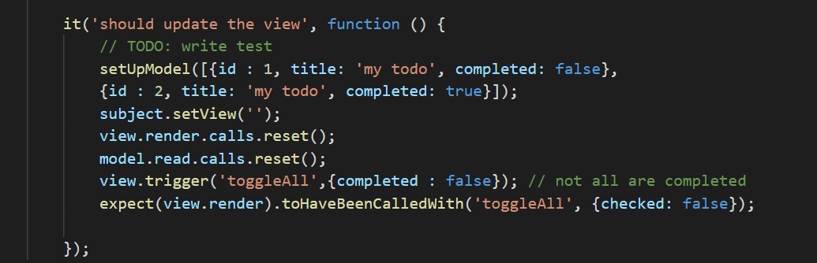

# should remove an entry from the model

# 

## 

## 

### **All tests were successful (see image below).**

## **Loading**

* PAGE LOADING TIME - 41ms
* DOM CONTENT LOADED TIME - 43ms
* NUMBER OF REQUESTS SENT - 11
* AMOUNT OF DATA TRANSFERRED - 41.7 KB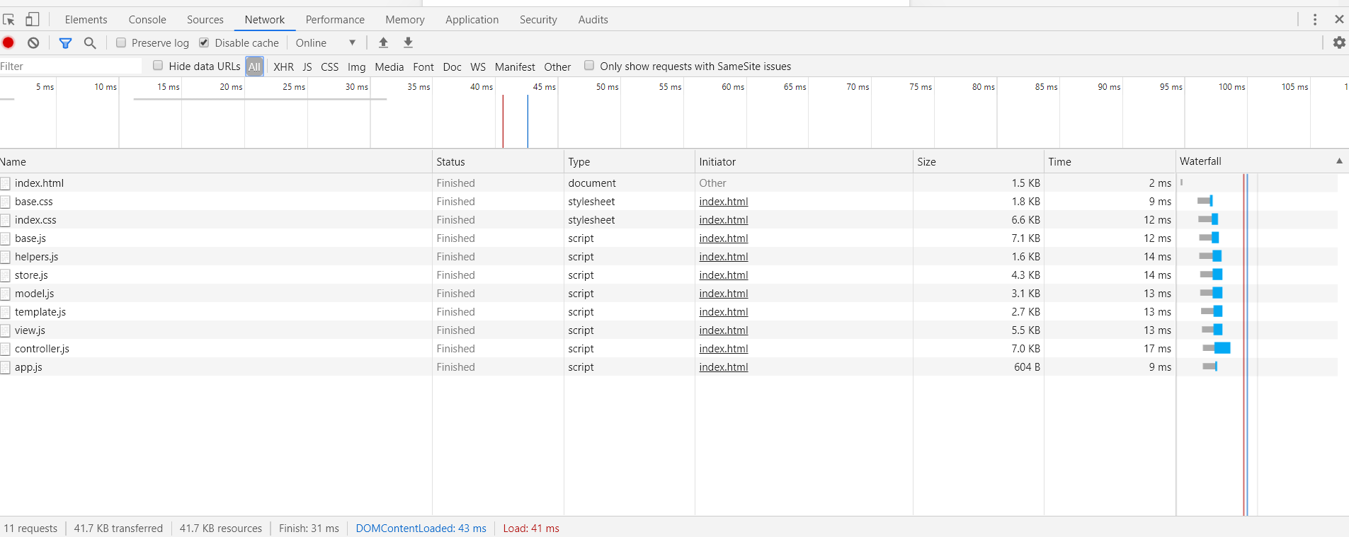

## 

## 

## 

## 

## 

## 

## **Memory**

Total Amount of Memory : 1.294MB

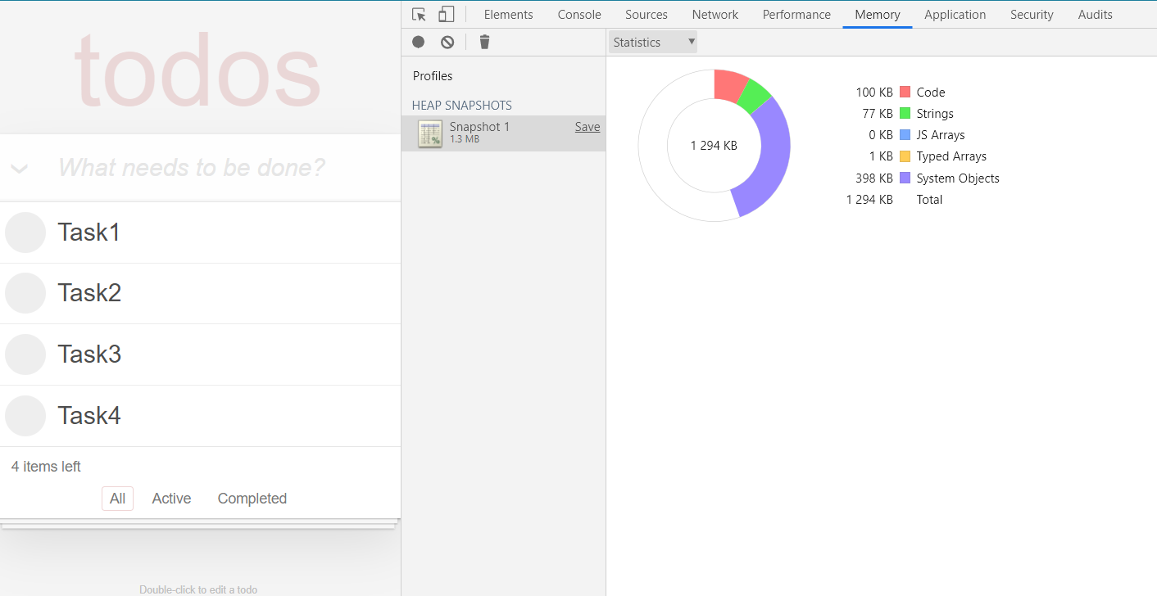

## 

## 

## 

## 

## 

## **User actions**

**Adding new task to the list - 5 s**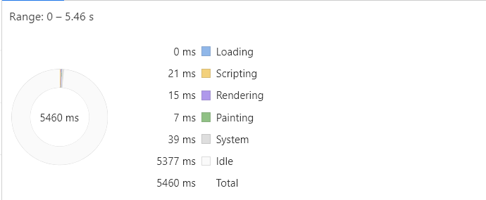

**Removing Task from List - 4s**

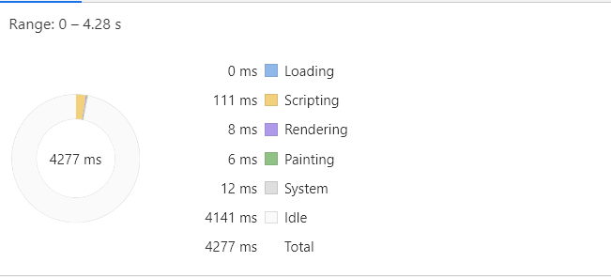

**Marking one task as completed - 3s**

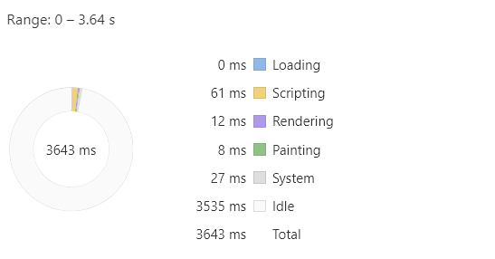

**Marking All tasks as completed 4.8s**

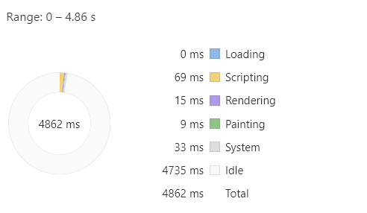

## **Audit results**

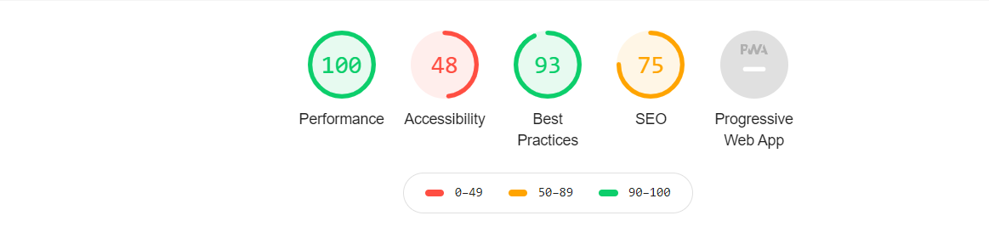

## **Improvements that should be made :**

**Performance 100**

**Accessibility 48**

* **Background and foreground colors do not have a sufficient contrast ratio.**
* **Form elements do not have associated labels**

**Best Practices 93**

* **Browser errors were logged to the console**

**SEO (search engine optimization)**

* **Does not have a <meta name="viewport"> tag with width or initial-scaleNo `<meta name="viewport">` tag found**
* **Document does not have a meta description**

# Competitors application is hosted under this link :

### <http://todolistme.net/>

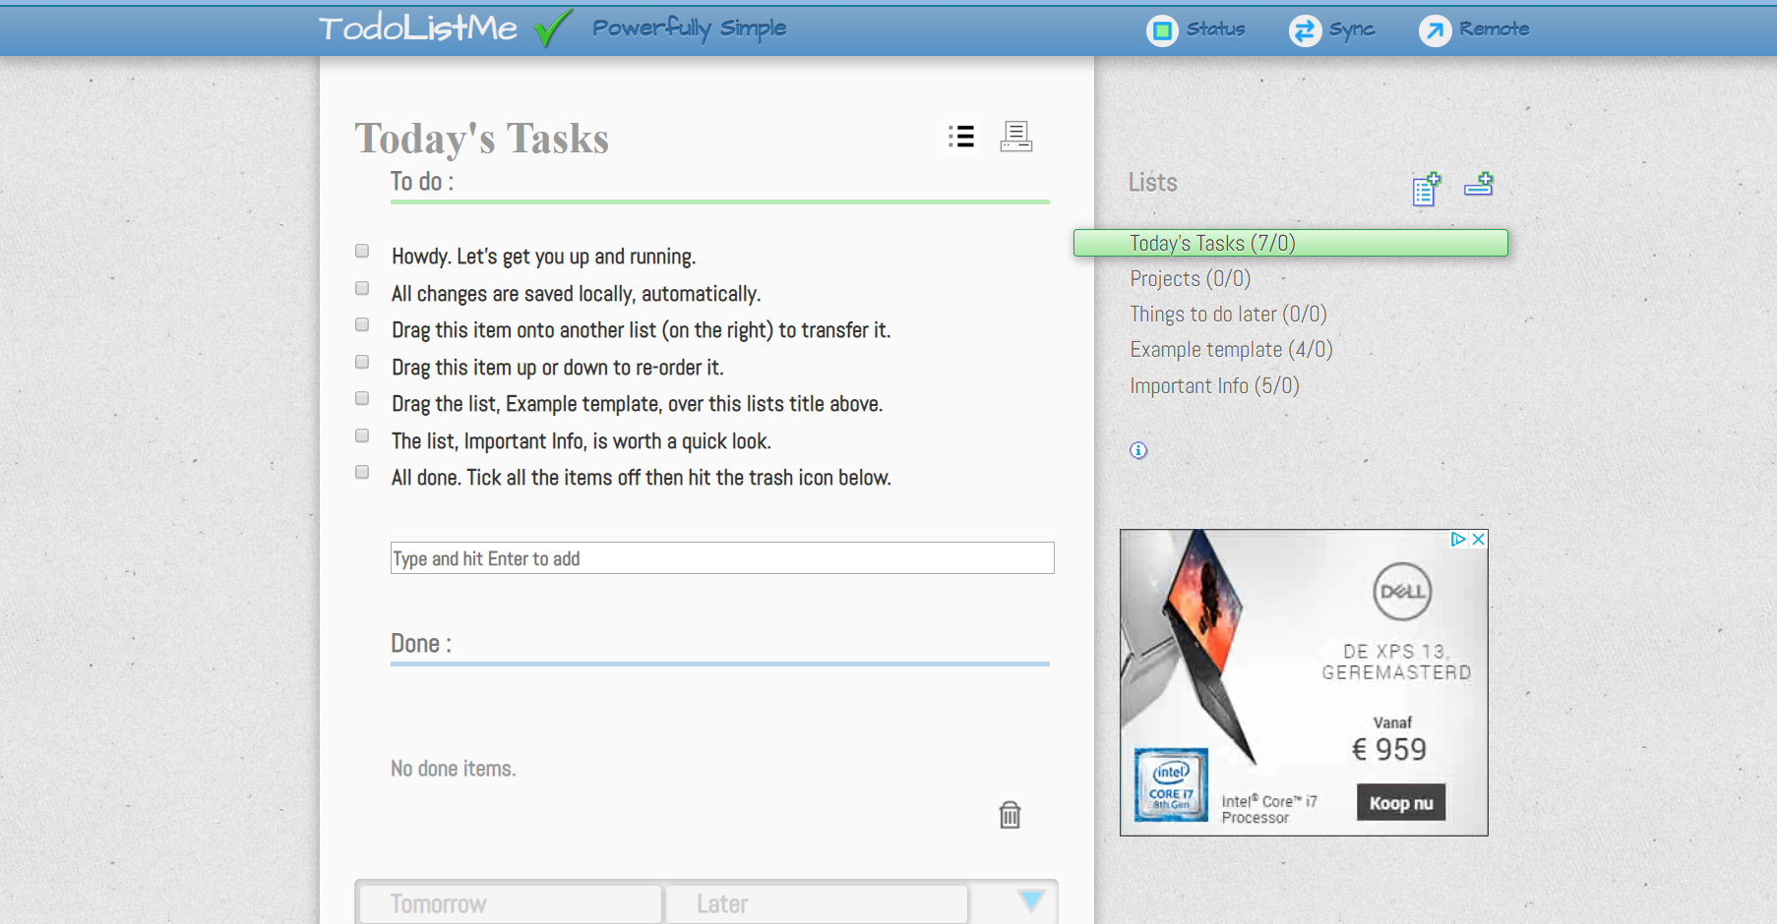

## **Loading**

* PAGE LOADING TIME - 2.56 s
* DOM CONTENT LOADED TIME - 821 ms
* NUMBER OF REQUESTS SENT - 36
* AMOUNT OF DATA TRANSFERRED - 525 KB

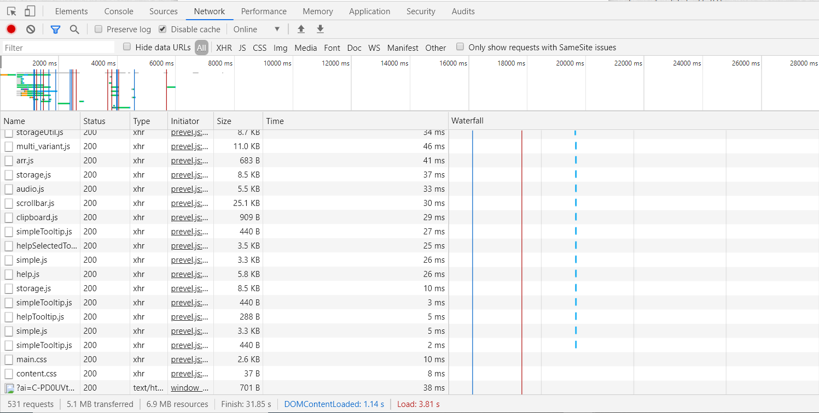

## **Memory**:

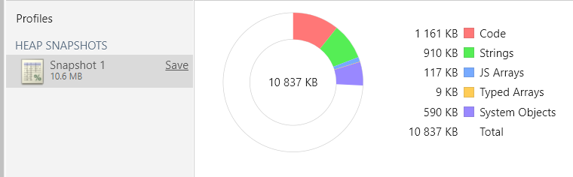

## 

## 

## 

## **User actions**

**Adding new task to the list - 5 s**

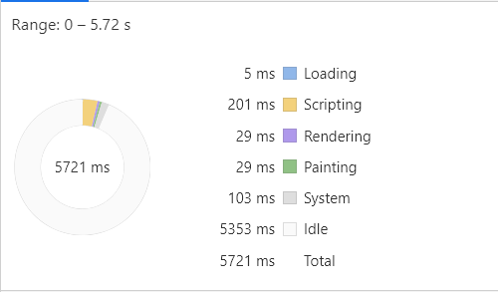

**Removing Task from List - 5s**

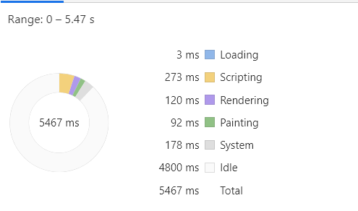

**Marking one task completed - 3s**

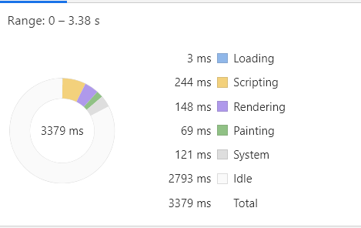

## **Audit results**

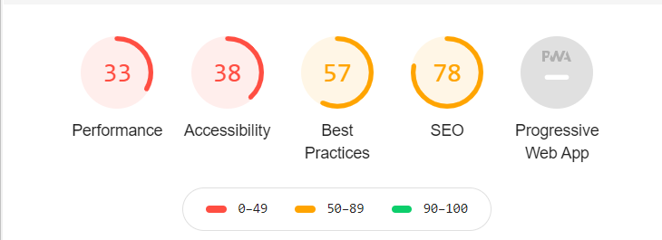

## **Improvements that should be made :**

## Background and foreground colors do not have a sufficient contrast ratio. Low-contrast text is difficult or impossible for many users to read.

## [id] attributes on the page are not unique. Failing Elements - span#later_number.

## <frame> or <iframe> elements do not have a title. Screen reader users rely on frame titles to describe the contents of frames.

## Image elements do not have [alt] attributes. Informative elements should aim for short, descriptive alternate text.

## Form elements do not have associated labels. Labels ensure that form controls are announced properly by assistive technologies, like screen readers. Failing Elements - input#newtodo.newtodonormal and other 7 inputs.

## <html> element does not have a [lang] attribute. If a page doesn't specify a lang attribute, a screen reader assumes that the page is in the default language that the user chose when setting up the screen reader. If the page isn't actually in the default language, then the screen reader might not announce the page's text correctly.

## Does not use HTTPS. All sites should be protected with HTTPS, even ones that don't handle sensitive data. HTTPS prevents intruders from tampering with or passively listening in on the communications between your app and your users.

## Uses document.write(). For users on slow connections, external scripts dynamically injected via document.write() can delay page load by tens of seconds.

## Includes front-end JavaScript libraries with known security vulnerabilities. Some third-party scripts may contain known security vulnerabilities that are easily identified and exploited by attackers. Library Version - jQuery@2.2.4 / Vulnerability Count - 2.

## Does not have a <meta name="viewport"> tag with width or initial-scale. Add a viewport meta tag to optimize your app for mobile screens.

## Document doesn't use legible font sizes. Font sizes less than 12px are too small to be legible and require mobile visitors to “pinch to zoom” in order to read.

## Tap targets are not sized appropriately. Tap targets are too small because there's no viewport meta tag optimized for mobile screens. Interactive elements like buttons and links should be large enough (48x48px) and have enough space around them to be easy enough to tap without overlapping onto other elements.

## Image texture.png used for background is definitely too big (size). Time to load it takes 562 ms (over half second). It needs to be changed for a smaller image and set in css as background-image with repetition to fill up the entire page.

## Some of the advertisements content is loaded as images. It takes a lot of time.

## Too many inline styles have been found in the code. They should be moved into an external css file.

# Our Todo List App

### **Advantages (+)**

* Short loading time
* Low memory usage
* Short time of performing functionalities
* Clean and readable code
* Perfect commented code
* Simple design

### **Disadvantages (-)**

* Limited functionality
* Only local storage is used to save data (Data is lost after cookies are being cleaned).

# Competitors Todo List Me App

### **Advantages (+)**

* Ability to sort tasks (Normal, Alphabetical, Random and Top 3)
* Ability to print lists
* Ability to drag and drop tasks
* User can create multiple lists
* User can create categories
* Data can be saved on a remote

### **Disadvantages (-)**

* Long loading time
* High memory usage
* Long time of performing functionalities

## 